Passing Variables from powershell to a runbook

|  |
| --- |
| Import-Module .\OrchestratorServiceModule.psm1"  $ServiceURL = "http://chevmg76:81/Orchestrator2012/Orchestrator.svc/"  $RunbookGUID = "cd17d120-7286-4ce9-9632-0357761325c4"  $runbook = Get-OrchestratorRunbook -ServiceUrl $ServiceURL -RunbookId $RunbookGUID  $parmGUID = "c726a644-8659-4b33-8e23-aa0d03658354"  $parameters = @{$parmGUID = "MyStringToPassToRunbook"}  Start-OrchestratorRunbook -Runbook $runbook -Parameters $parameters |

1. Install Powershell module this is just extracted and placed in a location choice of your own be sure to place the correct file path to the .psm1 file location after the import-module
2. $ServiceURL is the web hook into the Orchestrator Server
3. $RunbookGUID is the GUID of the actual runbook you can get this from the Ochestrator Console browse to the actual runbook and click on it then the GUID will be displayed in the browser address bar (Fig 1.0).

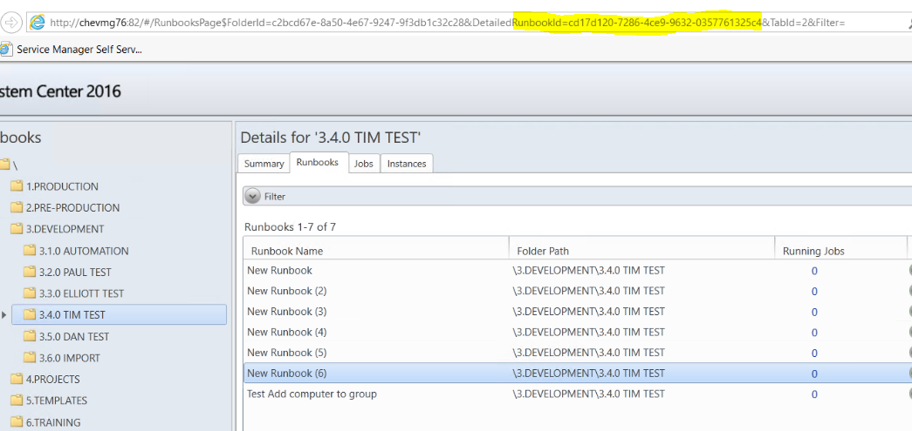

1. $runbook joins the web hook and the runbook GUID connection string together.
2. $paramGUID is the GUID of the actual Parameter in the Initialize Data for each Parameter there is a GUID these GUID letters must be in lower case or you will get an 500 error from the server.
3. $parameters contains the Parameter GUID and the value to be passed
4. Then last line starts the runbook and passes the variables over

Directaccess 2016 runbook create html snip

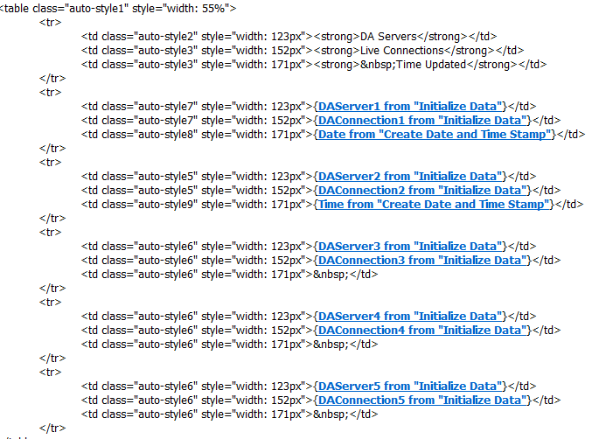

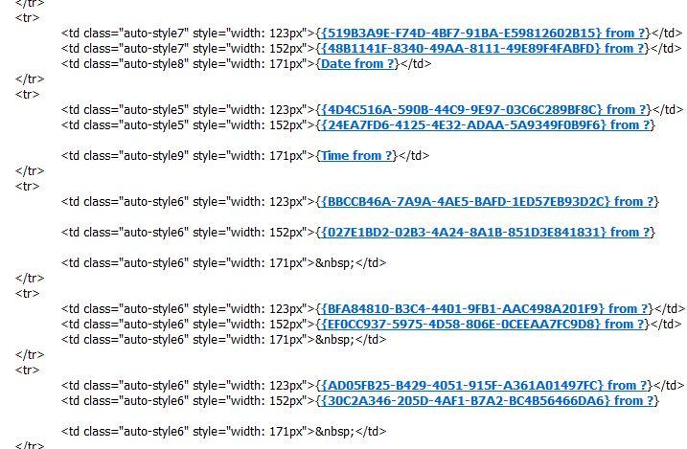

$ServiceURL = "http://chevmg76:81/Orchestrator2012/Orchestrator.svc/"

$RunbookGUID = "2276d0c7-dd67-4cdc-9009-8d66d14033f1"

$runbook = Get-OrchestratorRunbook -ServiceUrl $ServiceURL -RunbookId $RunbookGUID

$parmGUID = "c726a644-8659-4b33-8e23-aa0d03658354"

$parameters = @{"519b3a9e-f74d-4bf7-91ba-e59812602b15"=$DAServer1;"48b1141f-8340-49aa-8111-49e89f4fabfd"=$DA1;"4d4c516a-590b-44c9-9e97-03c6c289bf8c"=$DAServer2;"24ea7fd6-4125-4e32-adaa-5a9349f0b9f6"=$DA2;"bbccb46a-7a9a-4ae5-bafd-1ed57eb93d2c"=$DAServer3;"027e1bd2-02b3-4a24-8a1b-851d3e841831"=$DA3;"bfa84810-b3c4-4401-9fb1-aac498a201f9"=$DAServer4;"ef0cc937-5975-4d58-806e-0ceeaa7fc9d8"=$DA4;"ad05fb25-b429-4051-915f-a361a01497fc"=$DAServer5;"30c2a346-205d-4af1-b7a2-bc4b56466da6"=$DA5}

#Start-OrchestratorRunbook -Runbook $runbook -Parameters $parameters